City of Gibbon
Large Dumpster Request Form
Contract information is handled Monday through Friday 8-4:30pm

Contact Person: __________________________________ Contact Number: _____________________

Mailing Address: ______________________________________________________________________

Email Address: ________________________________________________________________________

Name of Dumpster Owner: ______________________________________________________________

Size of dumpster in cubic yards: __________________________________________________________

Address Dumpster will be located: _______________________________________________________

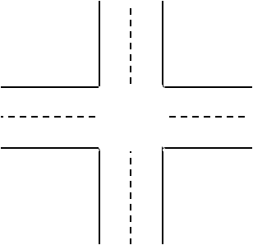
Sketch an outline of the property showing the location of buildings in relation to the dumpster and cones () below:

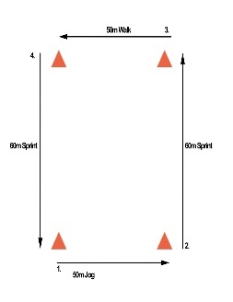

I have read the Ordinance 94.11 for regulations reguarding adding a temporary dumpster. I understand the requirements and agree to abide by them. I understand that violation may be cause for revocation of this permit.

_________________________________________ _____________________________
Signed by: Date

For Office Use Only:

Contract Received: ___________________________________________________

Received by: ________________________________________________________

Request Form #: ____________ ______________________________________

